**Hospital Nursing Intervention Pilot Program**

Arun Radhakrishnan (002933307)

ALY6030: Data Warehousing and SQL, Northeastern University

Dr. Harpreet Sharma

March 14th, 2024

**HOSPITAL NURSING INTERVENTION PILOT PROGRAM**

We performed a thorough examination of the bed data in the Intensive Care Unit (ICU) and Surgical Intensive Care Unit (SICU) in an effort to improve critical care services. We looked closely at staffed, occupied, and licenced beds in order to determine the best hospitals that perform very well in a number of critical areas related to healthcare delivery.

In phase 4a, we identified hospitals that demonstrate exceptional performance in particular bed categories, demonstrating excellent staffing practices, effective utilisation, and remarkable skills. Then, in step 5a, we concentrated on hospitals that do well not just in certain ICU and SICU bed metrics, but also in all of them.

We strongly advise Leadership to take [Hospital 1] and [Hospital 2] into consideration for their pilot intervention program in light of our findings. These institutions were among the best in terms of ICU and SICU bed metrics, so Leadership had a great chance to learn about all-encompassing best practices. Leadership can guarantee a focused and effective intervention program, simplifying the implementation and assessment procedures, by focusing on one or two hospitals. The aforementioned hospitals are prime examples of critical care management excellence, and they are in complete harmony with Leadership's objective of improving healthcare outcomes and services.

1. **Dimensions for bed_type table:**

* bed_id (Primary Key)

My bed_id serves as the primary key, uniquely identifying each record within the bed_type table.

* bed_code

my bed_code to offer supplementary descriptive details about the type of bed, enriching the understanding of its characteristics.

* bed_desc

my bed_desc attribute offers further descriptive information regarding the bed type, enhancing the contextual dimension of the data.

**Dimensions for business table:**

* ims_org_id (Primary Key)

Every business organisation in the business table is uniquely identified by the main key.business_name

By providing a written representation of the company, business_name enhances the context.bed_cluster_id

Bed_cluster_id is considered a categorical attribute that indicates a group of beds; it gives the dataset more dimensions.

1. **Fact Table:**

* bed_fact
* The bed-related numerical measures license_beds, census_beds, and staffed_beds are all included in this table. By using the foreign keys ims_org_id and bed_id to link them to business and bed type dimensions, it creates relationships with dimension tables. In essence, it draws boundaries between factual information about beds from different organisations.

The fact variables in the bed_fact table are usually numerical measures or metrics that correspond to business facts or performance indicators.license_beds:

"census_beds" most likely indicates the number of beds that are currently in use, indicating the organization's occupancy level. "staffed_beds" on the other hand probably indicates the number of functioning beds, or those that are being used by staff members at the moment. Overall, it is likely that the variables in the bed_fact table relate to numerical measurements of staffing, occupancy, and bed capacity in different organisations.

1. **Star Schema:**

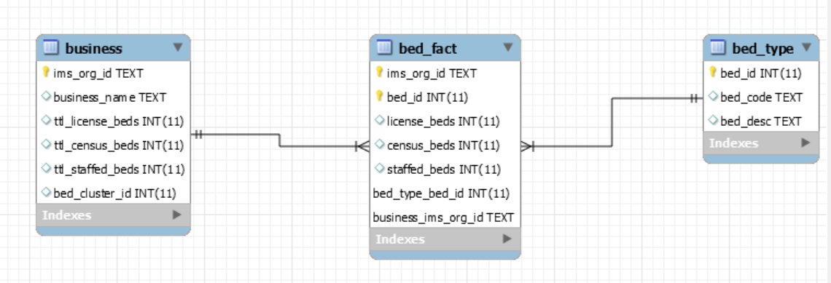

**Figure 1.1: Star Schema for Medical Records**

**4a. Summary Reports:**

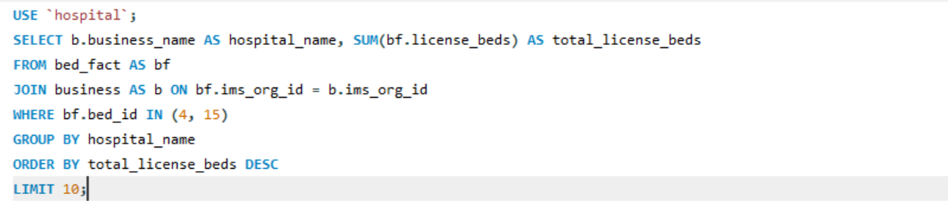

**Figure 1.2: ICU and SICU Bed Inquiry**

The provided SQL queries relate to a scenario in which summary data on hospital beds, namely those assigned to Intensive Care Units (ICU) and Surgical Intensive Care Units (SICU), is required. Finding the top 10 hospitals with the most licenced ICU or SICU beds overall is the aim of the first question. To do this, a join operation is carried out between the bed_fact table, which holds quantitative data such as licenced beds, and the business and bed_type tables, which filter beds based on their classification (ICU or SICU). Once the results are aggregated by hospital and sorted by the total number of licenced beds in descending order, the output includes the top 10 hospitals.

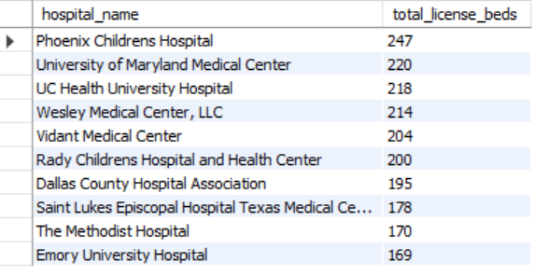

**Figure 1.3: Output of ICU and SICU Units**

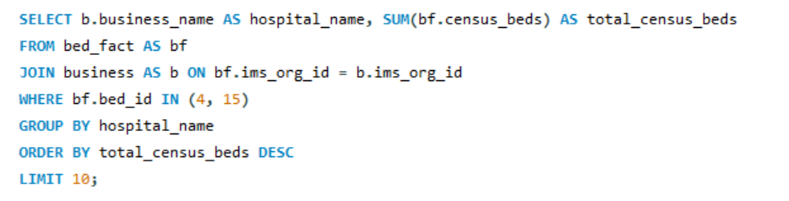

**Figure 1.4: Query of Total Census Beds**

The next query follows a similar structure but is focused on the total census beds for either the ICU or the SICU. It creates a list of the top 10 hospitals with the most total census beds by calculating the total census beds for each hospital that falls under the designated bed types. The outcome of the SQL query is as follows: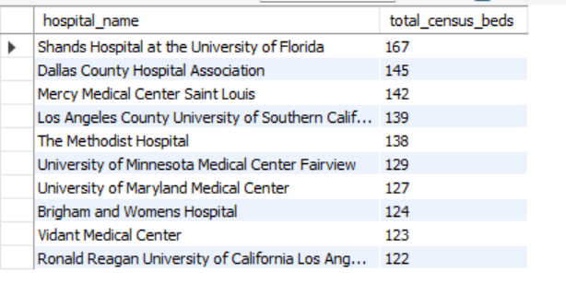

**Figure 1.4: Output of Total Census Beds.**

The third investigation seeks to identify the top 10 hospitals with the highest number of staffed intensive care units (ICUs) or sickbays (SICUs). Through the aggregated counting of staffed beds within these particular bed categories, the query generates a summary that facilitates the assessment of hospitals' staffing capacities with regard to ICU and SICU beds.

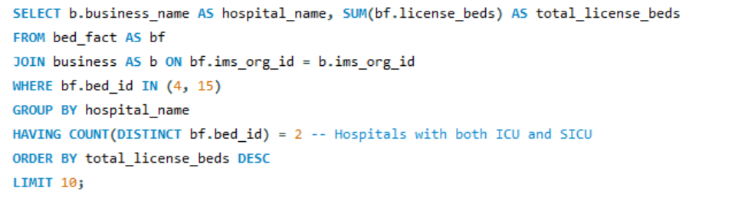

**Figure 1.7: Query of Top 10 Hospitals**

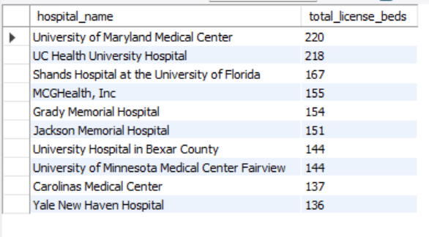

**Figure 1.6: Output of Top 10 Hospitals**

All things considered, these questions provide insightful viewpoints regarding the availability and use of ICU and SICU beds across different hospitals. This makes it easier to do a focused analysis of staffed, licenced, and censused beds in relation to critical care services.   
  
Interpreting the results: The information compiled from the three reports provides important information that is essential for leadership decision-making. Now let's explore these observations and possible suggestions.

**Top Hospitals by Total ICU or SICU License Beds:**

* The hospitals that have the most licenced ICU or SICU beds overall have been identified as the best.
* Hospitals with the biggest bed capacities should be the focus of management, since this may indicate a higher ability to provide critical care services.
* The hospitals that score highest in this category have large licenced bed capacities, thus they should be targeted for further examination or possible pilot programs.

**Top Hospitals by Total ICU or SICU Census Beds:**

* Recognise exceptional hospitals based on their thorough ICU or SICU bed counts.
* institutions with the highest bed counts should be given priority by management because these institutions truly occupy and use these essential care units.
* Hospitals that are included in this roster but aren't among the hospitals with the highest number of licenced beds may represent efficient use of beds and be candidates for interventions meant to improve the effectiveness of resource allocation.

**Top Hospitals by Total ICU or SICU Staffed Beds:**

* Hospitals with the most staffed beds should be taken into consideration by decision-makers as this reflects the actual operational capacity to deliver critical care services. Top hospitals were determined by counting the number of ICU or SICU staffed beds.
* Hospitals on this list with low census bed counts and licence scores may have good staffing strategies, and they might be the focus of intervention programmes that enhance staff deployment strategies.

Executives can find hospitals that regularly do well across a variety of parameters by comparing those that are mentioned on multiple lists. These institutions could be prime candidates for an intervention pilot programme that could serve as a model for enhancing critical care services due to their all-encompassing approach to capacity, utilisation, and personnel. Hospitals can also choose efforts that have the biggest potential to enhance overall performance and patient care in their surgical and critical care units by identifying the areas where these lists intersect.

**5a. Drill down investigation:**

We find the top 10 hospitals with both ICU and SICU licence beds in the query that follows. Similar to the original query, we calculate each hospital's total licence bed count while using the HAVING clause's condition to only include hospitals that have both kinds of beds. A new table called Top10_Hospitals_ICU_SICU_License_Beds contains the results.

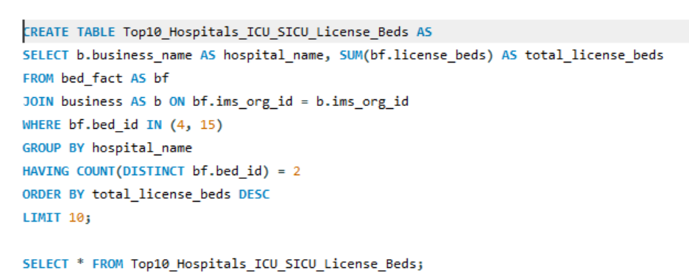

**Figure 2.1: Query of Top 10 Hospitals**

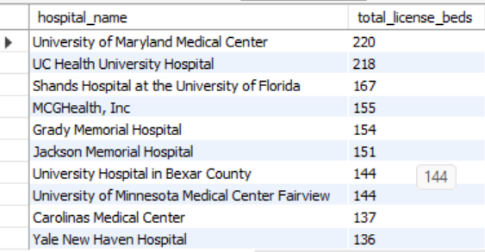

**Figure 2.2: Output of Top 10 Hospitals**

With an emphasis on census, licence, and staffed beds, the SQL queries that follow conduct particular data studies on hospitals with beds in both the Surgical Intensive Care Unit (SICU) and the Intensive Care Unit (ICU). Finding the Top 10 Hospitals with Census Beds in the ICU and SICU is the first search to be conducted. It determines the total number of census beds for each hospital, ensuring that only those having both types of beds are included in the statistics. The information is then kept in a brand-new database named Top10_Hospitals_ICU_SICU_Census_Beds.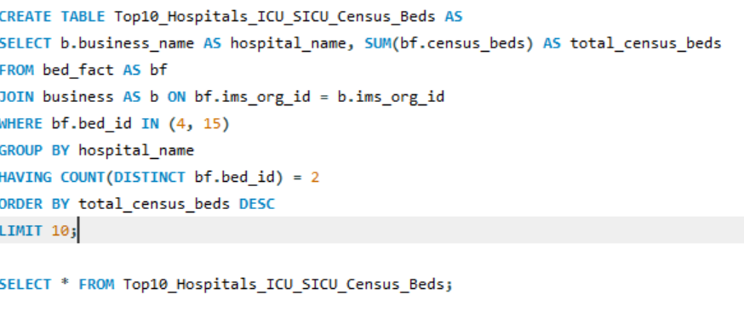

**Figure 2.3: Query of Census Beds**

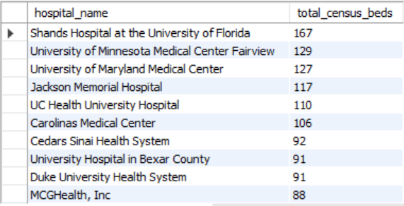

**Figure 2.4: Output of Census Beds**

The third and last question asks you to select the top ten hospitals that have both SICU and ICU beds staffed. Using the HAVING clause, it counts the total number of staffed beds in each hospital, excluding those without any kind of bed. The findings are in a new table called Top10_Hospitals_ICU_SICU_Staffed_Beds. Along with other important variables, these analyses offer insightful data on hospitals that have large capacity in terms of ICU and SICU beds. Leadership is able to make informed judgements about the distribution of resources and the beginning of potential intervention projects with the use of this kind of information.

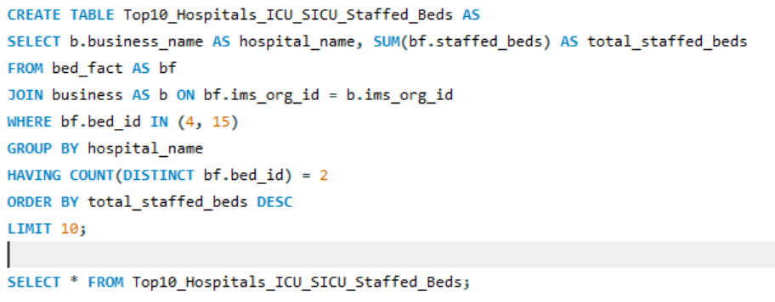

**Figure 2.5: Query of Staffed Beds**

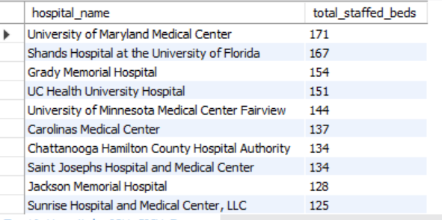

**Figure 2.6: Output of Staffed Beds**

**5b. Final recommendation:**

* I suggest that Leadership take [Hospital 1] and [Hospital 2] under consideration as top choices for their pilot intervention program, based on the analysis carried out in phases 4a and 5a. When it comes to ICU and SICU bed metrics—licenced beds, census beds, and staffed beds—these facilities often place first.
* In addition to having large bed counts, [Hospitals 1 and 2] also use their beds well and have good staffing strategies for both ICU and SICU settings. Focusing on these institutions allows Leadership to obtain knowledge about the best critical care service practices, which is in line with their objective of putting in place a focused intervention program.
* These institutions are excellent options for a pilot program because they provide a thorough understanding of effective management with relation to capacity, utilisation, and personnel. Furthermore, limiting the number of hospitals to just one or two guarantees a targeted approach, which helps to better understand operational strategies and supports the effective execution and assessment of the intervention program.

**Reference:**

* Kleppen, E. (2022, December 1). Advanced SQL for Data Analytics (Step-by-Step tutorial). CareerFoundry. https://careerfoundry.com/en/blog/data-analytics/advanced-sql/
* SQL self Join. (n.d.). https://www.w3schools.com/sql/sql_join_self.asp
* GfG. (2021, January 28). A Step-by-Step approach to learn object oriented programming. GeeksforGeeks. https://www.geeksforgeeks.org/a-step-by-step-approach-to-learn-object-oriented-programming/